**Discussion**

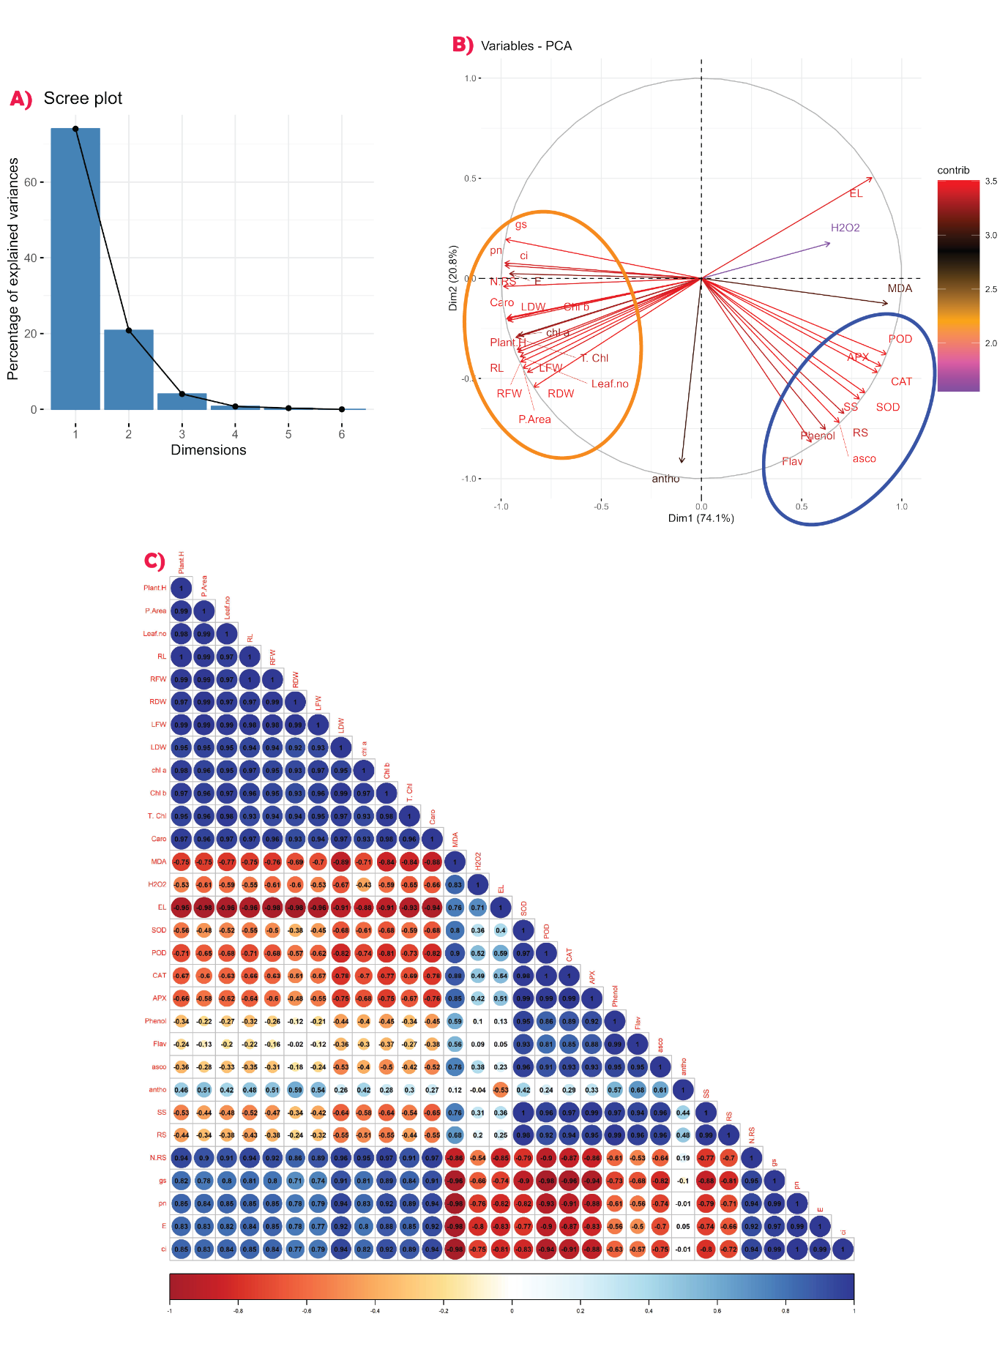**Figure :** A) Presenting the scree plot presenting the data divided into principal component, B) presenting the circular biplot between two principal components from scree plot C) presenting the Correlation matrix graph between all parameters discussed in paper.

In **figure ((above-number as per paper need) C)** presenting thecorrelation as, P. Area is highly positively correlated with plant height. Leaf no. has highly positively correlated with Plant. H and P. area. RL has highly positive correlation with Plant. H, P. area and Leaf .no. RFW highly positive correlated Plant. H, P. area, Leaf. No and RL. RDW highly positive correlated with Plant. H, P. area, Leaf. No, RL and RFW. LFW highly positive correlated with Plant. H, P. area, Leaf. No, RL, RFW and RDW. LDW highly positive correlated with Plant. H, P. area, Leaf. No, RL, RFW, RDW and LFW. Chl *a* highly positive correlated with Plant. H, P. area, Leaf. No, RL, RFW, RDW, LFW and LDW. Chl *b* highly positive correlated with Plant. H, P. area, Leaf. No, RL, RFW, RDW, LFW, LDW and Chl *a.* T. Chl highly positive correlated with Plant. H, P. area, Leaf. No, RL, RFW, RDW, LFW, LDW, Chl *a* and Chl *b*. Caro highly positive correlated with Plant. H, P. area, Leaf. No, RL, RFW, RDW, LFW, LDW, Chl *a,* Chl *b* and T. Chl. MDA highly negative correlated with highly positive correlated with Plant. H, P. area, Leaf. No, RL, RFW, RDW, LFW, LDW, Chl *a,* Chl *b*, T. Chl and Caro. H2O2 highly negative correlated with P. area, RFW, RDW, LDW, T. Chl and Caro have moderately negative correlation with Plant. H, Leaf. No, RL, LFW, Chl *a* and Chl *b* and highly positive correlated with MDA. EL highly negative correlated with Plant. H, P. area, Leaf. No, RL, RFW, RDW, LFW, LDW, Chl *a,* Chl *b*, T. Chl and Caro, have highly positive correlation with MDA and H2O2. SOD highly negative correlated with Plant. H, Leaf. No, RL, RFW, LDW, Chl *a*, Chl *b* and Caro, moderately negative correlated with P. area, RDW and LFW, highly positive correlated with MDA and moderately positive correlated with H2O2 and EL. POD highly negative correlated with Plant. H, P. area, Leaf. No, RL, RFW, RDW, LFW, LDW, Chl *a,* Chl *b*, T. Chl and Caro, and positively correlated with MDA, H2O2, EL and SOD. CAT highly negative correlated with Plant. H, P. area, Leaf. No, RL, RFW, RDW, LFW, LDW, Chl *a,* Chl *b*, T. Chl and Caro, have highly positive correlation with MDA, EL, SOD and POD, have moderately positive correlation with H2O2. APX highly negative correlated with Plant. H, P. area, Leaf. No, RL, RFW, LFW, LDW, Chl *a,* Chl *b*, T. Chl and Caro, moderately correlated RDW, have highly positive correction with MDA, EL, POD, SOD and CAT, moderately positive correlated with H2O2. Phenol have moderately negative correlation with Plant. H, P. area, Leaf. No, RL, RFW, RDW, LFW, LDW, Chl *a,* Chl *b*, T. Chl and Caro, have highly positive correlation with MDA, POD, SOD, CAT and APX, have moderately positive correlation with EL and H2O2. Flav have moderately negative correlation with Plant. H, P. area, Leaf. No, RL, RFW, RDW, LFW, LDW, Chl *a,* Chl *b*, T. Chl and Caro, have highly positive correlation with MDA, POD, SOD, CAT, APX and Phenol, have moderately positive correlation with EL and H2O2. Asco highly negative correlated with LDW, Chl *b* and Caro, have moderately negative correlation with Plant. H, P. area, Leaf. No, RL, RFW, RDW, LFW, Chl *a* andT. Chl, have highly positive correlation with MDA, POD, SOD, CAT, APX, Phenol and Flav, have moderately positive correlation with EL and H2O2. Antho highly positive correlated with P. area, RFW, RDW, LFW, Phenol, Flav and Asco, have moderately positive correlation with Plant. H, Leaf No., RL, LDW, Chl *a,* Chl *b*, T. Chl, Caro, MDA, POD, SOD, CAT and APX, have highly negative correlation with EL and moderately negative with H2O2. SS highly negative correlated with Plant. H, RL, LDW, Chl *a,* Chl *b*, T. Chl and Caro, moderately negative correlated with P. area, Leaf. No, RDW, LFW and LDW, highly positively correlated with MDA, SOD, POD, CAT, APX, Phenol, Flav and Asco, have moderate positive correlation with H2O2, EL and antho. RS highly negative correlated with LDW, Chl *a,* Chl *b* and Caro, moderately negative correlated with Plant. H, P. area, Leaf. No, RL, RFW, RDW, LFW and T. Chl, highly positively correlated with MDA, SOD, POD, CAT, APX, Phenol, Flav, Asco and SS, have moderate positive correlation with H2O2, EL and antho. N.RS highly positive correlated with Plant. H, P. area, Leaf. No, RL, RFW, RDW, LFW, LDW, Chl *a,* Chl *b*, T. Chl and Caro, moderate positive correlation with antho, highly negative correlated with MDA, H2O2, EL, SOD, MDA, SOD, POD, CAT, APX, Phenol, Flav, Asco, SS and RS. *gs* highly positive correlated with Plant. H, P. area, Leaf. No, RL, RFW, RDW, LFW, LDW, Chl *a,* Chl *b*, T. Chl, Caro and N.RS, highly negative correlated with MDA, H2O2, EL, SOD, MDA, SOD, POD, CAT, APX, Phenol, Flav, Asco, SS and RS, moderately negative with antho. *pn* highly positive correlated with Plant. H, P. area, Leaf. No, RL, RFW, RDW, LFW, LDW, Chl *a,* Chl *b*, T. Chl, Caro, N.RS and *gs,* highly negative correlated with MDA, H2O2, EL, SOD, MDA, SOD, POD, CAT, APX, Phenol, Flav, Asco, SS and RS, moderately negative with antho. *E* highly positive correlated with Plant. H, P. area, Leaf. No, RL, RFW, RDW, LFW, LDW, Chl *a,* Chl *b*, T. Chl, Caro, N.RS, *gs* and *pn,* moderately positive with antho, highly negative correlated with MDA, H2O2, EL, SOD, MDA, SOD, POD, CAT, APX, Phenol, Flav, Asco, SS and RS. Ci highly positive correlated with Plant. H, P. area, Leaf. No, RL, RFW, RDW, LFW, LDW, Chl *a,* Chl *b*, T. Chl, Caro, N.RS, *gs, pn* and *E*, highly negative correlated with MDA, H2O2, EL, SOD, MDA, SOD, POD, CAT, APX, Phenol, Flav, Asco, SS and RS, moderately negative with antho.

In **figure (stated above) B),** presenting the principal component analysis (PCA) plot among all variables like biochemical and physiological. This graphical layout presents the relation and expression between two principal components which are labeled as Dim 1, contributing 74.1% and Dim 2, contributing 20.8% totally comprising of 94.9%. Encircles points are in highly positive correlation with each other and contribute a major share in the growth and improvement of plant development.